

# UNIVERSITY INSTITUTE OF ENGINEERING

**Department of Computer Science & Engineering**

**Subject Name:** Competitive Coding-II

**Subject Code:** 20CSP-351

**Submitted to: Submitted by:**

Mr. Arvind Gautam Name: Nabha Varshney UID: 20BCS4995

Section: 20BCS_DM-704 Group: A

**INDEX**

|  |  |  |  |  |  |  |  |
| --- | --- | --- | --- | --- | --- | --- | --- |
| **Ex. No** | **List of Experiments** | **Date** | **Conduct (MM: 12)** | **Viva (MM: 10)** | **Record (MM: 8)** | **Total (MM: 30)** | **Remarks/**  **Signature** |
| 1.1 |  |  |  |  |  |  |  |
| 1.2 |  |  |  |  |  |  |  |
| 1.3 |  |  |  |  |  |  |  |
| 2.1 |  |  |  |  |  |  |  |
| 2.2 |  |  |  |  |  |  |  |
| 2.3 |  |  |  |  |  |  |  |
| 2.4 |  |  |  |  |  |  |  |
| 3.1 |  |  |  |  |  |  |  |
| 3.2 |  |  |  |  |  |  |  |
| 3.3 |  |  |  |  |  |  |  |

# Experiment1.1

## Student Name: Nabha Varshney UID: 20BCS4995

**Branch: CSE Section/Group: 20BCS-DM-704 (A)**

## Semester: 6th Date of Performance: 15th Feb 2023 Subject Name: Competitive Coding II Subject Code: 20CSP- 351

**Aim** - To demonstrate the concept of string matching algorithm.

## Objective-

* The objective is to build problem solving capability and to learn the basic concepts of data structures.
* The implementation of rotate string which shows and brushes up the concept of strings and can be solved through various approaches.
* The implementation of repeated string matching in which the concept of npos was introduced.

## Rotate String

**https://leetcode.com/problems/rotate-string/ Code –**

class Solution {

    public boolean rotateString(String s, String goal) {

        return s.length()== goal.length() && (s+s).contains(goal);

    }

}

## Output -

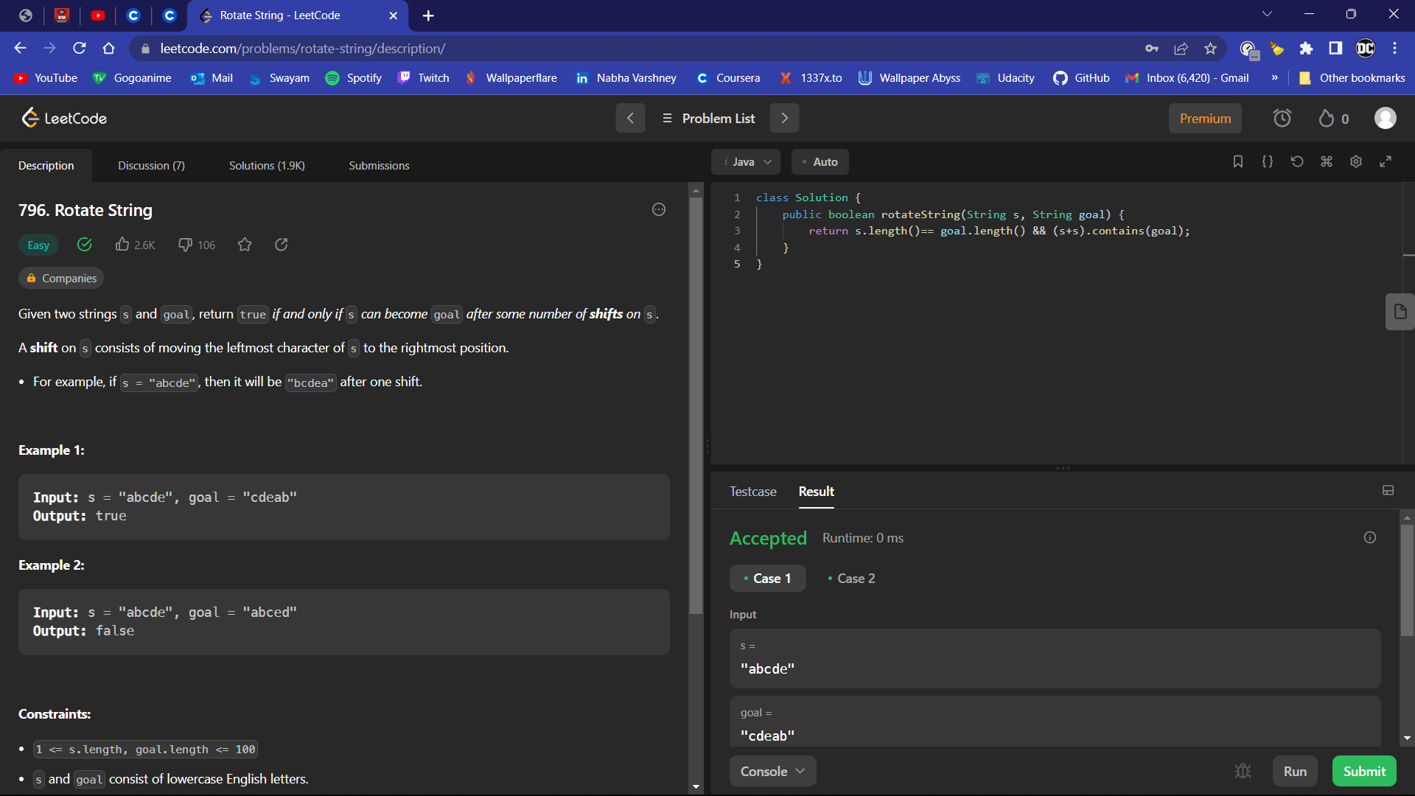

1. **Repeated String https://leetcode.com/problems/repeated-string-match/ Code -**

class Solution {

    public int repeatedStringMatch(String A, String B) {

        String str=A;

        int repeat=B.length()/A.length();

        int count=1;

        for(int i=0;i<repeat+2;i++)

        {

            if(A.contains(B))

            return count;

            else{

                A+=str;count++;

            }

        }

        return -1;

    }

}

## Output -

